MEANDER
The Story of a One-Off Ocean-Going Gaff Ketch
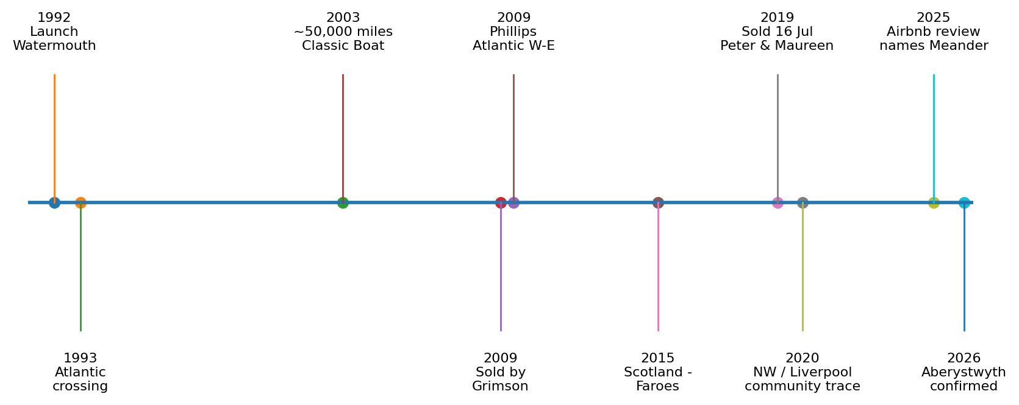
Built 1990-1992 • Atlantic voyager • Bahamas liveaboard • Scotland & Faroes • Liverpool • Aberystwyth
Final research edition • August 2026
A documented history assembled from owner accounts, contemporary articles, sailing records, association archives and independent cruising evidence.

Contents
- Meander at a glance
- Conceived and built in North Devon, 1990-1992
- Bob and Jean Grimson: a home, studio and ocean yacht
- The Atlantic years, 1993-2009
- 2009: return across the Atlantic and Chris Phillips
- Scotland, refit and the 2015 Faroe Islands voyage
- Peter and Maureen Hennessey: the Liverpool years
- From Liverpool to Aberystwyth
- How Meander changed through the years
- Ownership and voyage chronology
- What is known and still unresolved
- Can you help complete Meander's story?
- Principal sources

1. Meander at a glance
Meander is a one-off ferro-cement gaff ketch designed and built by Robert G. 'Bob' Grimson as a long-distance liveaboard home. Launched at Watermouth Harbour in 1992, she has since lived several distinct lives: ocean cruiser with Bob and Jean Grimson, Atlantic voyager and Scottish cruising yacht under Chris Phillips, North-West/Liverpool boat with Peter and Maureen Hennessey, and finally the present Aberystwyth chapter.
Particular | Recorded detail
Name | MEANDER
Type | Traditional gaff ketch; one-off ocean-going liveaboard
Hull | Ferro-cement over galvanised steel armature
Built | 1990-1992, Ilfracombe / North Devon
Launched | Watermouth Harbour, 1992
Designer / builder | Robert G. Grimson
Length | About 37-38 ft on deck; approximately 45-49 ft overall including spars
Beam | About 11 ft 6 in / 3.5 m
Draft | About 5 ft 6 in / 1.7 m
Displacement | About 12 tonnes
Engine | Beta Marine 43 hp diesel, fitted 2014
MMSI / call sign | 235068491 / 2BQR2
SSR / ship number | 46501
OGA | 3434

Bob's biography explains the name 'Meander' as 'Me and Her' - an affectionate reference to Bob and Jean and to the wandering life for which the yacht was created.

2. Conceived and built in North Devon, 1990-1992
Bob Grimson was both sailor and marine artist. After reconnecting with Jean, whom he had known at school, the couple married in 1987 and planned a boat that could serve simultaneously as home, cruising yacht and painting studio. Rather than buying a production yacht, Bob designed and built Meander himself at Ilfracombe over roughly two years.
Her hull drew on the character of North American working craft while the finished rig developed into a traditional British gaff ketch. Construction was ferro-cement over a galvanised steel armature. In his 2003 Classic Boat article Bob put the material build cost at about £23,000 including a new suit of sails.
The interior was practical and sea-going: double cabin, saloon seating around a fixed table, bookshelves and storage, solid-fuel stove, U-shaped galley and heads. Larch and mahogany featured heavily, together with some pitch pine salvaged from Ilfracombe pier.

Rig evolution
The yacht evolved in use. The original mizzen was Bermudan and fully battened with a yard topsail. During winter 1995 Bob converted it to gaff rig and later added a main topmast and jib-headed topsail. The resulting tan-sailed profile became one of Meander's signatures.

3. Bob and Jean Grimson: a home, studio and ocean yacht
For roughly eighteen years Meander was Bob and Jean's home, not merely a holiday yacht. Bob painted aboard, Jean shared the cruising life, and the boat became the platform for an extraordinary period of Atlantic voyaging.
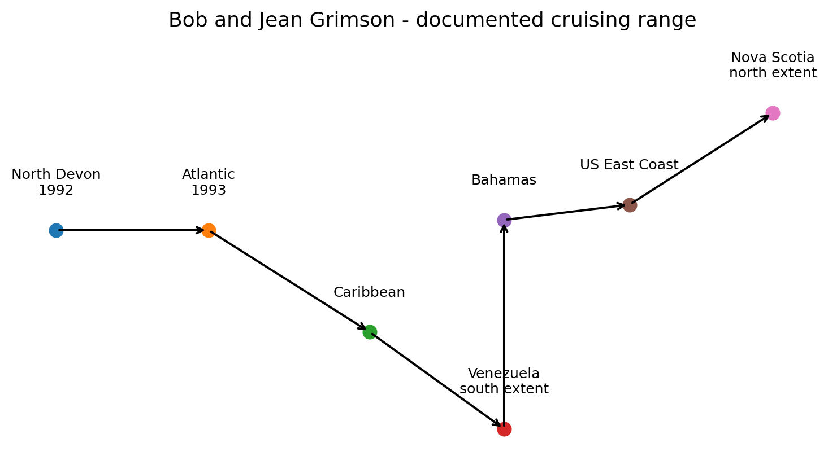
Bob's biography records a 1993 Atlantic crossing, followed by cruising as far south as Venezuela and as far north as Nova Scotia. The Bahamas became particularly associated with Meander. By 2003 Bob reported almost 50,000 miles in ten years.

Independent Bahamas evidence - 2008
A separate cruising log provides unusually strong late-Grimson corroboration. On 8 April 2008 the yacht Alisios recorded anchoring at Rock Sound, Eleuthera, beside a British-flagged gaff-rigged ketch from Ilfracombe named Meander. The writer added that they had already anchored beside Meander at Long Island. This independently places the yacht in the Bahamas only about a year before the 2009 sale.
Bob's art catalogue adds personal sailing clues including Chesapeake Bay, Delaware Bay and Mahone Bay, Nova Scotia. These are retained as research leads rather than automatically treated as confirmed Meander ports.

4. The Atlantic years, 1993-2009
Period / place | What the evidence establishes
1993 | Atlantic crossing under Bob and Jean Grimson.
Bahamas | Major recurring cruising area.
Caribbean / Venezuela | Venezuela is the documented southern extent.
North America | Documented range extends north to Nova Scotia.
2003 | Nearly 50,000 miles reported after about ten years.
Feb-Apr 2008 | Independent sightings at Long Island and Rock Sound, Eleuthera.
2009 | Bob and Jean sell Meander when upkeep becomes too demanding.

Art Marine notes that Bob made three Atlantic crossings in boats he built himself. The first two belonged to his earlier boat Carius; Meander's 1993 passage was the third. Keeping those voyages separate avoids attributing Carius history to Meander.

5. 2009: return across the Atlantic and Chris Phillips
Chris Phillips records a two-handed west-to-east Atlantic crossing aboard Meander in 2009. He received the Royal Naval Sailing Association's Tim Sex Trophy for the passage, an award associated with outstanding seamanship in an offshore yacht.
Later material identifies Alec Townley as the companion whose watchkeeping system Chris had used during that 2009 crossing. The exact departure and arrival ports and full dates remain to be recovered.
The Nobby Owners Association independently says that after Meander was sold in 2009 she was sailed back to Britain and that her next owner cruised mainly around Scotland. That closely matches the Phillips history.

The Peter Bunting / Arklow question
Indexed Old Gaffers Association material also associates Peter Bunting with Meander, saying he found her laid up in Arklow and cruised her with a growing family. Its exact chronological position remains unresolved. The episode is therefore preserved as a genuine lead rather than forced into the settled ownership sequence.

6. Scotland, refit and the 2015 Faroe Islands voyage
Under Chris Phillips, Meander became closely associated with western Scotland. She was ashore from September 2013 until May 2015 for extensive work. A Beta Marine 43 hp diesel was fitted in 2014, replacing the Perkins 4.108. She was relaunched in Loch Creran on 4 May 2015.
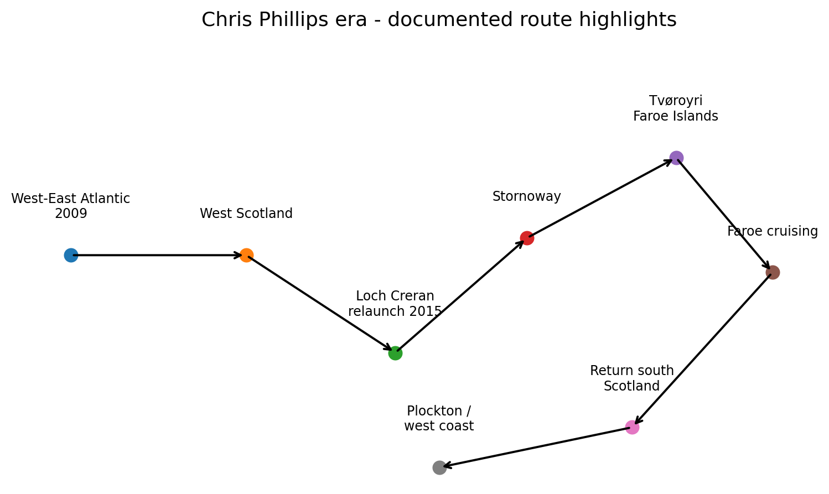

2015 route reconstructed from Chris's dated logs
- Loch Creran / Barcaldine - relaunch and trials
- Oban / Kerrera / Dunstaffnage - preparation
- Tobermory - Ardnamurchan - Inverie, Knoydart
- Rona - Stornoway
- Stornoway - North Rona / Sula Sgeir area - Tvøroyri, Suðuroy
- Tvøroyri - Sandur - Miðvágur - Tórshavn
- Tórshavn - Kinlochbervie
- Ullapool - Summer Isles - Tanera Beg - Loch Erisort - Stornoway
- Plockton - Mallaig - Tobermory - Puilladobhran
- 5 August 2015 - return to Loch Creran / Barcaldine
The voyage demonstrates that more than twenty years after launch Meander remained a serious offshore cruising yacht. Chris sold her on 16 July 2019 after purchasing the bare steel hull for his next expedition yacht.

7. Peter and Maureen Hennessey: the Liverpool years
Chris's sale notice names the new custodians simply as Peter and Maureen. The Nobby Owners Association supplies the surnames: Peter and Maureen Hennessey. Its dedicated Meander history says that in 2019 they brought her to the North West and that she was normally berthed in Liverpool.
This turns the Liverpool chapter from recollection into documentary history. It is reinforced by Meander's association with a traditional sailing community centred on Liverpool Bay, the Mersey and the Irish Sea.

Conwy River Festival, 2021
Official 2021 results show Peter Hennessey helming Meander in the 'Nobbys, Gaffers and Classics' race, finishing second. The record proves she remained an actively sailed yacht during the Liverpool era and travelled from her North-West base to North Wales.

8. From Liverpool to Aberystwyth
The least documented modern transition is Liverpool to Aberystwyth. No publicly indexed bill of sale, departure date, delivery passage or first marina record has yet been found.
By June 2025 the evidence is firm: an Aberystwyth accommodation guest review explicitly names the boat as Meander. The current listing is titled 'Pirate luxury!'. Hosting an accommodation listing is not evidence of legal ownership, so the present title-holder should not be inferred from the host name.
In August 2026 Meander is physically present at Aberystwyth Marina and can be matched to the historic yacht through her distinctive hull, deckhouse, spars and ketch configuration. The remaining gap is therefore narrow: the precise date and circumstances of the move from Liverpool.

9. How Meander changed through the years
Period | Known change
1990-92 | Original hull, liveaboard interior and initial rig completed.
Winter 1995 | Mizzen converted from Bermudan to gaff.
Later Grimson era | Main topmast and jib-headed topsail added.
c. 2002 | Cockpit well reduced during plywood repair work.
2013-15 | Major Scottish refit while ashore.
2014 | Perkins 4.108 replaced by Beta Marine 43 hp diesel.
2015 | Hull paint, antifouling, spar varnish and rig preparation before Faroes cruise.
2019 onward | Liverpool liveaboard / cruising chapter; finer alteration record still sought.
Aberystwyth era | Accommodation use while retaining the recognisable historic vessel.

Meander's survival is partly a story of continuous adaptation: Bob altered the rig through experience at sea; Chris renewed machinery and structure; later custodians kept a large, unusual traditional yacht in use.

10. Ownership and voyage chronology
Year / period | People | Event
1990-92 | Bob & Jean Grimson | Designed and built; launched Watermouth.
1993 | Bob & Jean | Atlantic crossing.
1993-2009 | Bob & Jean | Long-distance liveaboard cruising; Bahamas, Venezuela to Nova Scotia.
2008 | Grimson era | Independent Bahamas sightings.
2009 | Transition | Grimsons sell; west-to-east Atlantic return.
2009-2019 | Chris Phillips | Scottish cruising, major refit and Faroes expedition.
16 Jul 2019 | Peter & Maureen Hennessey | Purchase from Chris Phillips.
2019 onward | Hennesseys | North West / Liverpool base.
2021 | Peter Hennessey | Races Meander at Conwy.
By Jun 2025 | Aberystwyth period | Accommodation review explicitly identifies Meander.
Aug 2026 | Aberystwyth | Meander present at Aberystwyth Marina.

11. What is known and still unresolved
The central life story is now well supported. The remaining questions concern transitions and fine detail rather than the identity or broad history of the yacht.
Status | Question
Resolved | 2019 buyers: Peter and Maureen Hennessey.
Resolved | Liverpool is documented by the Nobby Owners Association.
Resolved | Meander remained actively sailed in 2021.
Open | Where exactly does Peter Bunting's Arklow episode fit?
Open | Exact ports and dates of Chris's 2009 Atlantic crossing.
Open | Precise Liverpool Marina/liveaboard dates.
Open | Date, route and ownership circumstances of Liverpool-to-Aberystwyth transfer.
Open | Current legal owner.
Open | Original construction and 1992 Watermouth launch photographs.

12. Can you help complete Meander's story?
Former owners, crew, marina neighbours, Old Gaffers and Nobby members, cruising sailors, photographers and local historians may hold material that is not indexed online. Even a single dated photograph or logbook entry could close one of the remaining gaps.
Construction and launch, 1990-1992 — Photos of the armature/hull, fitting-out, spars and Watermouth launch.
Bob and Jean's cruising — Dated photos or logs from the Bahamas, Caribbean, Venezuela, US east coast or Nova Scotia.
The 2009 Atlantic passage — Departure/arrival ports, dates, photographs and Alec Townley's role.
Peter Bunting and Arklow — When Meander was laid up there, how Bunting became involved and how the episode fits the chain.
Scotland and the Faroes — Additional pre/post-refit and 2015 expedition photographs.
Liverpool, 2019-24 — Dated Liverpool Marina photographs, liveaboard dates, work undertaken and neighbouring-boat recollections.
Liverpool to Aberystwyth — Sale/transfer evidence, delivery passage and earliest dated Aberystwyth record.

How to assess new evidence
Where possible, contributions should include a date, location and explanation of provenance. Original photographs are especially valuable when supported by metadata, album captions or logbooks. Memories are valuable too, but should be identified as recollections rather than documentary facts.

13. Principal sources
Nobby Owners Association - Meander
Chris Phillips / SERCHTHRIFT - Meander
Chris Phillips - About the Author
Davidson Fine Art - Bob Grimson biography
Art Marine - Bob Grimson collection
Classic Boat, December 2003 - Bob the Builder
Conwy River Festival - 2021 results
Significant Deviation - ICW and Bahamas cruising log
ITU MARS List V
Airbnb - Aberystwyth room 854238688764278012
MEANDER
North Devon • Atlantic • Bahamas • Scotland • Faroes • Liverpool • Aberystwyth

